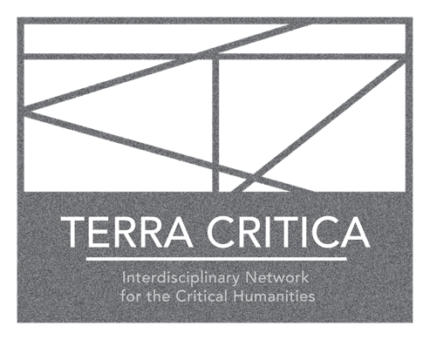
international one-day workshop

Terran Critique:
Toward a Different
Critical Vocabulary

Pontificia Universidad
Católica de Valparaíso

29 November 2024
10.00-17.30

Sala Redes Biblioteca, Campus Sausalito PUCV
Av. El bosque 1290, Viña del Mar, Chile

organized by
Dr. Valeria Campos Salvaterra (PUCV) with Terra Critica

***

This intensive, one-day workshop is a collaboration between the Instituto de Filosofía of Pontificia Universidad Católica de Valparaíso and the international research network Terra Critica: Interdisciplinary Network for the Critical Humanities (http://terracritica.net/). Going into its second decade of research, Terra Critica reexamines critical theory and critique under conditions of the 21st century – given our terran existences, globally entangled in ecological and economic multi-dependences, with the limits of planetary exhaustion in sight.

Together, the Instituto de Filosofía and Terra Critica invite researchers and cultural practitioners to think about “terra" as a perspective or concern from which to reflect on transformations of the critical vocabulary in view of “terran critique”. What are the practical methodologies and the ethico-onto-epistemological as well as cosmological attitudes needed to move deeper toward a different critical vocabulary? Do more than hu/man entanglements and intensified socio-ecological depletion require such changed critical vocabularies? And what can be the conceptual tools to analyze and intervene into the global “terran” present? This workshop suggests taking “terra” – earth, planet, soil, land – as conceptual and methodological entry-point to think about how practices of critique and socio-cultural-cum-natural analysis can take meaningful shape today.

Participants

Noelia Billi (Universidad de Buenos Aires, Buenos Aires, Argentina)
Mercedes Bunz (King's College London, UK)
Valeria Campos Salvaterra (Pontificia Universidad Católica de Valparaíso, Chile)
Alejandro Fielbaum (Université Paris VIII, France)
Raul Rodríguez Freire (Pontificia Universidad Católica de Valparaíso, Chile)
Birgit M. Kaiser (Utrecht University, The Netherlands)
Jacques Lezra (University of California at Riverside, USA)
Noortje Marres (University of Warwick, UK)
Fernanda Medina (Universidad Adolfo Ibáñez, Santiago de Chile, Chile)
Omar Molina (Pontificia Universidad Católica de Valparaíso, Chile)
Marjorie Peñailillo (Gigigraffiti) (Artista Educadora, Graffiti School Comunidad Chile/ CipCrc Limache (Sename))
Valeria de los Ríos (Pontifical Catholica de Chile, Santiago de Chile, Chile)
Andrea Roland-Rodriguez (European Graduate School, Saas-Fee, Switzerland)
Lorena Souyris Oportot (Universidad Católica del Maule, Talca, Chile)
Andrés Maximiliano Tello (Universidad de Playa Ancha, Valparaíso, Chile)
Kathrin Thiele (Utrecht University, The Netherlands)
Shannon Winnubst (The Ohio State University, Columbus, USA)

Program

10.00-12.30
Morning session: Challenges and Inspirations of “Terra” for Critical Interventions

Mercedes Bunz, Alejandro Fielbaum, Jacques Lezra, Noortje Marres, Marjorie Peñailillo (Gigigraffiti), Lorena Souyris Oportot, Andrés Maximiliano Tello

12.30-14.30
Lunch break

14.30-16.30
Afternoon session: The many “terras” or “terran critique”

Valeria Campos Salvaterra, Birgit M. Kaiser, Fernanda Medina, Valeria de los Ríos, Andrea Roland-Rodriguez, Kathrin Thiele, Shannon Winnubst, Noelia Billi

16.30-17.00
Coffee break

17.00-17.30
closing session

***

